CAS PY 106

InClass Note 26

1. Energy and Intensity
2. More useful measure of how much energy is in an EM wave is not energy but intensity: power per unit area
3. Intensity = power/area = energy/time \* 1/area
4. 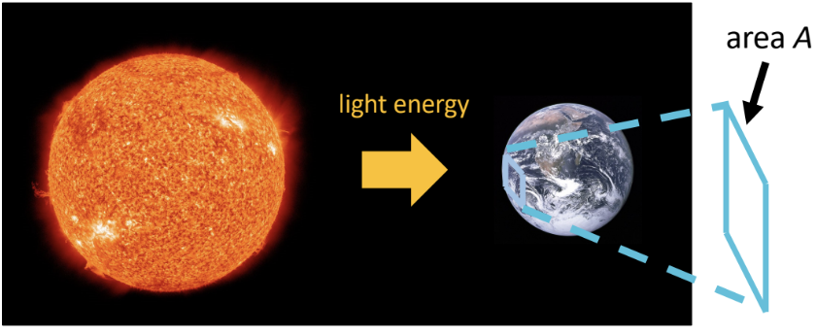
5. Unpolarized light
6. Sometimes the direction of the E-field is in all directions
7. We say that the wave is unpolarized (light from Sun)
8. Light Polarizer
9. A polarizer is a special material that only lets one direction through
10. 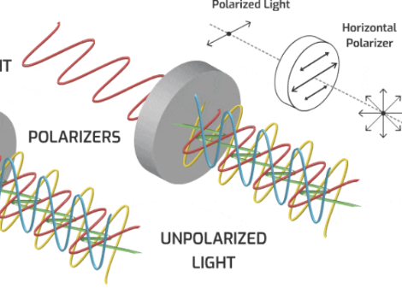
11. 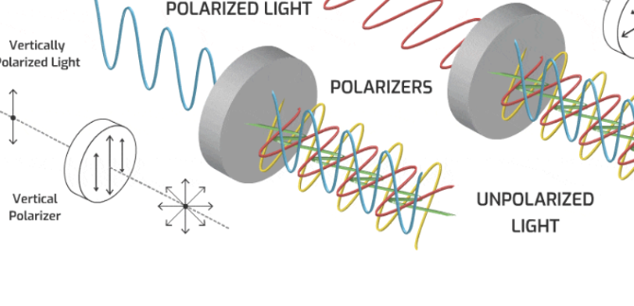
12. Polarizer
13. Imagine you pass unpolarized light through a polarizing filter
14. The light on the other side is polarized along the transmission axis
15. What is intensity of the polarized light?

Half the light goes through:

I = I0/2

1. 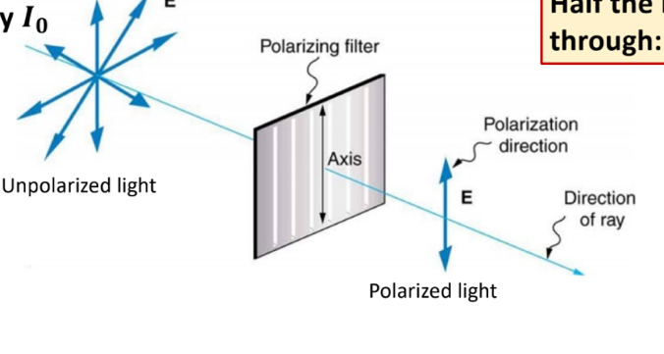
2. Passing polarized light through another polarizer
3. First polarize the light vertically. Then pass the vertically polarized light through another polarizer with varying alignment of transmission axes
4. 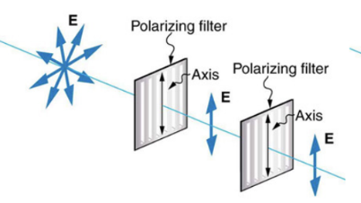
5. Intensity of vertically polarized light doesn’t change after it passes through the second vertical polarizer
6. 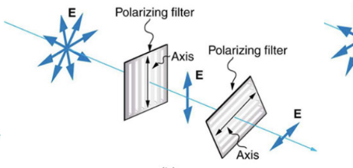
7. Intensity of vertically polarized light will be slightly less after passing through the second polarizer
8. 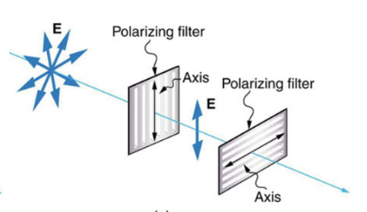
9. Intensity of vertically polarized light will be 0 after passing through the second polarizer
10. Malus’s Law
11. Light coming out has intensity:

I = I0\*cos2(theta) where theta is the angle between the polarization of the incoming light and the polarizer axis

1. Two polarizer example
2. 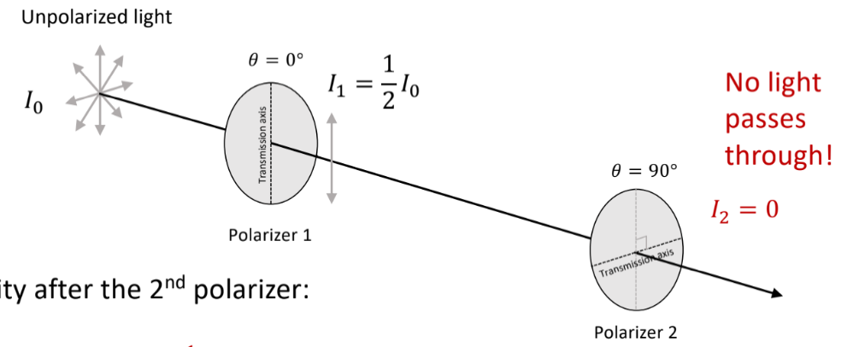
3. Intensity after 2nd polarizer:

I = I0\*cos2(theta) = ½ \* I0\*cos2(90) = 0

1. Three polarizer example
2. 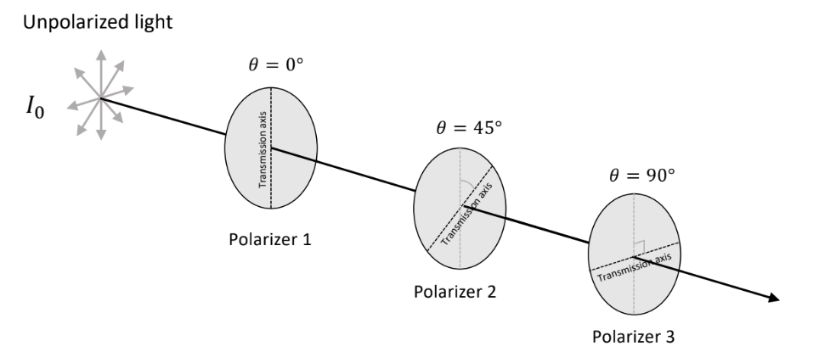
3. I2 = I1 \* cos2(45) = ¼ \* I0
4. I3 = I2 \* cos2(45) = ¼ \* I0 \* ½ = 1/8 \* I0